Lesson 1 Problem-Solving Practice
Using the Percent Proportion

1. A local Mothers group conducted a survey of 1074 youths age 19 and under about chores. 66% of those surveyed said they do not clean their rooms because they do not like to. How many of the 1074 youths gave that response? |  | Curbside Recycling  Programs  Region Number  Northeast 3421  South 1677  Midwest 3572  West 1034  Total 9704  2. The table shows the recent number of curbside recycling programs in four geographical regions of the United States. What percent of the country’s recycling programs are in the Midwest?
3. A recent Boston Mayor's Cup race boasted the largest number of finishers in the history of the event with 825 finishers. 290 of the finishers were from the youth division. What percent of the finishers were not from the youth division? Round your answer to the nearest tenth. |  | 4. Trevor received a score of 96% on his social studies test. If he answered 24 of the questions correctly, how many questions were on the test?
5. The U.S. Food and Drug Administration requires food packagers to provide nutritional information about the food in the packaging. The label shown is from a small package of chicken tenderloins, brown rice, and mixed vegetables.  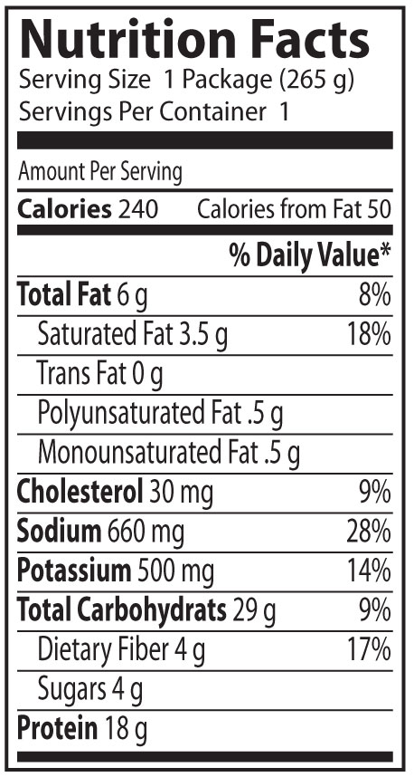 |  | 6. Refer to the label shown in Exercise 5. The potassium in the package is 14% of the recommended daily value. What is the recommended daily value of potassium?
 | According to the label, the package contains 6 grams of fat, which is 8% of the daily value recommended for a 2000-Calorie diet. How many grams of fat are recommended for a 2000-Calorie diet?

